**DEEPER LIFE HIGH SCHOOL**

**THIRD TERM E-LEARNING NOTE**

**SUBJECT: COMPUTER STUDIES CLASS: JSS 1(BASIC 7)**

**SCHEME OF WORK**

**WEEK TOPIC**

**SUB-THEME: BASIC KNOWLEDGE OF INFORMATION TECHNOLOGY**

**1. Revision of last term’s work.**

**2. Information Transmission**: (a) Meaning of Information transmission

**3. Information Transmission**: (b) Ancient methods of transmitting information: (i) Oral (ii) Beating drums (iii) Fire lighting

**4. Information Transmission**: (b) Ancient methods cont’d; (iv) Town-crying (v) Whistling (vi) Drawing diagrams (vii) Making representation.

**5. Information Transmission**: (c) Modern methods of transmitting information :(i) Print (ii) Telephone (iii) GSM

**6. Information Transmission**: (a) Modern methods cont’d; (iv) Telex (v) Radio/Television (vi) Fax (vii) Satellite (viii) Internet

**7- Mid Term Holiday**

**8-10. Revision**

**11-13 Examination**

**REFERENCES:**

* **HiiT Plc (2016) Computer Studies for Junior Secondary Education (JS1), HiiT Publisher, Nigeria Computer Society (NCS).**
* **Basic Science and Technology: Computer Studies for Junior Secondary Schools 1 by Wole Olatokun et al**
* **Searchlights on Computer Studies for JSS, Book 1 by Kayode Owolabi et al**

**WEEK 2**

**TOPIC: INFORMATION TRANSMISSION**

**CONTENT**

* Definition of Information Transmission
* Methods of transmitting information

**SUBTOPIC 1**

**DEFINITION OF INFORMATION TRANSMISSION**

**INFORMATION:** This is a data already processed into a meaningful form for decision making. Information conveys meaning and is useful to one or more people.

**TRANSMISSION:** This is the process of transferring something from one location to another location, from one person to another person or from one device to another device.

**INFORMATION TRANSMISSION**

Information transmission is the passing on or publishing of information to someone or a group of people in order to get the right responses. Some information when passed on or given requires a feedback while some do not require feedback. For example, information that the principal wants to meet with all JSS 1 students by 12 noon will make the students to go to his office. However, information that reminds students to be in their classes after break period does not mean that the students should go to the principal’s office.

**METHODS OF TRANSMISSION OF INFORMATION**

1. Ancient methods: This is the method of communication in the olden days without electronic medium.
2. Modern methods: This is the method of communication in the modern days with electronic devices.

**MODES OF INFORMATION TRANSMISSION**

1. **Synchronous Transmission:** This is a process where data is transferred in regular interval that are timed by clocking signal allowing for a constant and reliable transmission for time sensitive data such as real time video or voice. Examples are video conferencing
2. **Asynchronous Transmission:** This is like the opposite of synchronous, meaning that signal timing is not required.

**EVALUATION**

1. What is information transmission?
2. List the two methods of information transmission

**WEEKEND ASSIGNMENT**

What is the difference between Ancient method and Modern method of transmitting information?

**READING ASSIGNMENT**

Study and summarize the topic ‘Ancient methods of transmitting information’

**WEEK 3**

**TOPIC: INFORMATION TRANSMISSION**

**CONTENT**

**ANCIENT METHODS OF TRANSMITTING INFORMATION**

Ancient methods include the following:

1. **Oral method:** This is one of the oldest methods of transmitting information. It is the era of our great grandfathers when information is been sent to people through the use of the mouth.

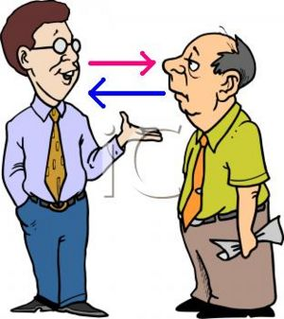

1. **Drum beating:** Beating the drums was a simple method of information transmission across distances. Explorers, fearfully making their way through a jungle, would hear the drums pick up tempo and volume and that would tell them that they were in enemy territory. However, far from being a source of terror, the drums in the jungles of Africa and Asia were more equivalent of local news.

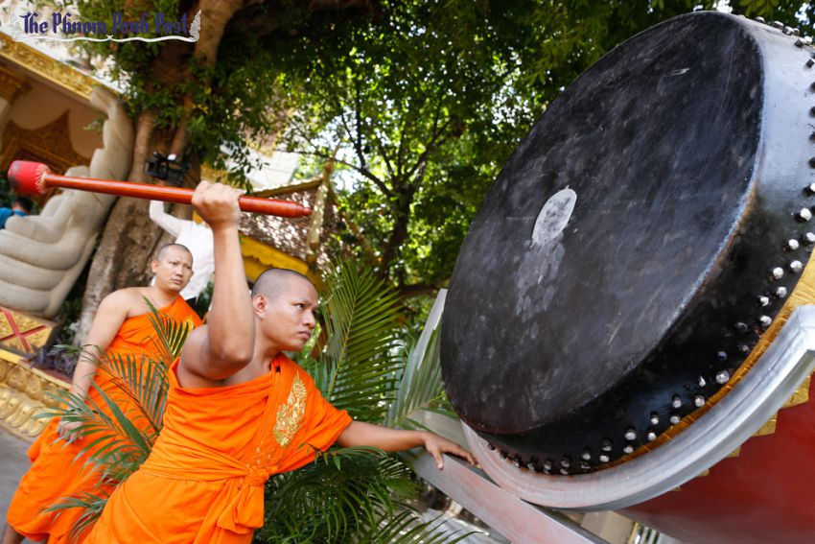

1. **Fire lighting:** Lighting fire has been used as a method of information transmission since the Trojan War; Bonfires were lit in succession, in a line, on hilltops, to send smoke signals in order to alert one another of an approaching enemy. But such methods were only capable of conveying very limited prearranged signal, such as danger or victory.

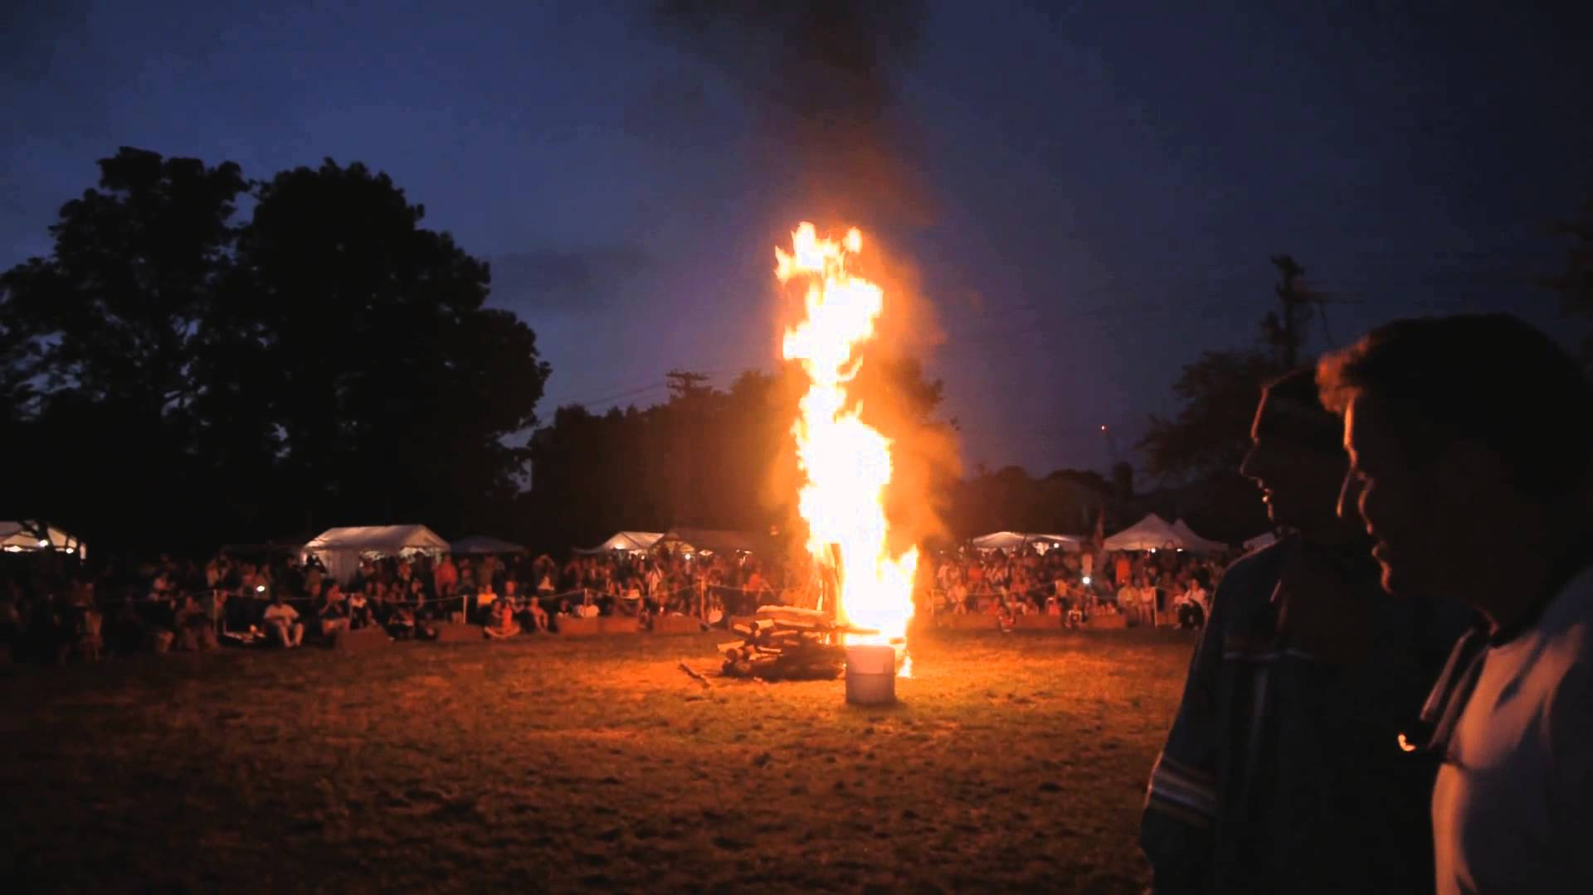

1. **Town crying:** In ancient times, town criers were the primary means of making announcements to a community. The town crier would read out the information and then nail the paper it was written on to a post in front of an inn for those who could read.

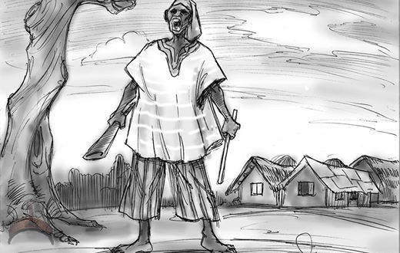

**EVALUATION**

1. Mention five ancient methods of transmitting information

2. State three advantages and three disadvantages of ancient methods of transmitting information

**WEEK 4**

**TOPIC: INFORMATION TRANSMISSION**

**CONTENT**

**Ancient methods of transmitting information (cont.)**

1. **Whistling:** This was a form of transmitting information used by many indigenous people around the world. Much like spoken language, this type of transmission had expressions and a vocabulary based on the language commonly used in the area and could convey a complex message over a long distance very easily.



1. **Drawing diagrams:** Diagrams have played a central role in understanding literature. This method was believed to have been used since prehistoric times to tell stories, warn of danger, and claim territories and so on.

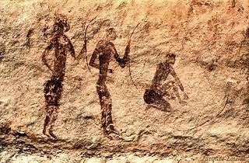

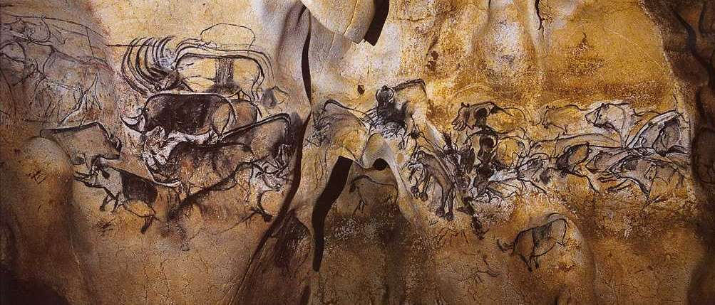

**vii. Making representation:** Information can be passed from one person to another by using symbols or things that bears resemblance to what the information represents. For example, a seller can put the exact amount he/she sells goods on it in his/her absence so that prospective buyers would know the amount the goods are been sold.

Although these are ancient methods, some communities still use some of them to transmit information. The reason may be because there are no other means or because they are cheaper to use e.g. Road signs and price tag.

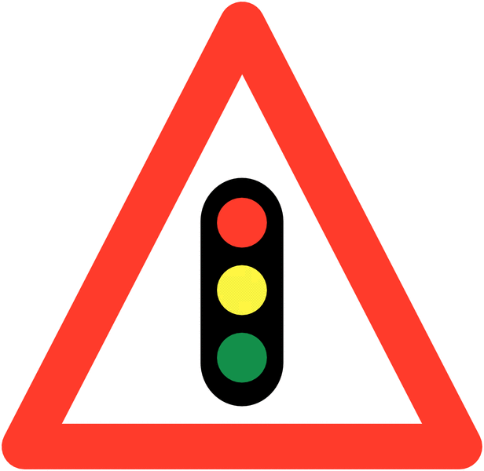 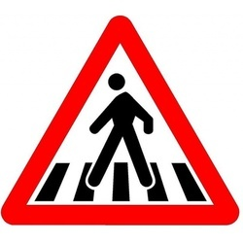 

**EVALUATION**

Briefly discuss THREE ancient methods of transmitting information mentioned above

**READING ASSIGNMENT:**

Students are to study the topic ‘Modern means of transmitting Information’

**WEEKEND ASSIGNMENT**

Fill in the blanks:

1. .­­­_______ is the process of communication from one entity to another

2. ________ method was used by explorers in the jungle to send terror to any intending enemy

3. In ancient times ______ were the primary means of making announcement to a community.

4. Open MS-PAINT and draw two ancient means of information transmission.

**WEEK 5**

**TOPIC: INFORMATION TRANSMISSION**

**CONTENT**

**MODERN METHODS OF TRANSMITTING INFORMATION**

1. Printing
2. Telephone
3. GSM

With modern inventions in communication, many ancient methods have been replaced with more efficient modern ways of transmitting information. These include the following;

1. Printing
2. Telephone
3. Telex
4. Facsimile (Fax)
5. Radio
6. Television
7. Satellite
8. Internet
9. Global Systems for Mobile communication (GSM), etc.
10. **Printing**: Information transmission by printing involves the production of information on paper using typewriter or others printing device/machine.



1. **Telephone**: Telephones allow people voices to be transmitted over a short or long distance, either by cables or by waves.

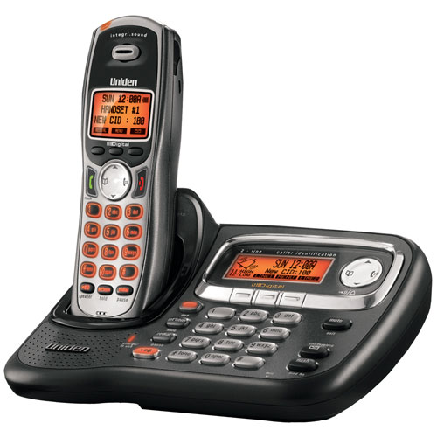

1. **Global System for Mobile-Communications (GSM):** GSM phones allow users to utilize one phone and a number or two in many different locations. This enables people to communicate using texts, pictures and voice, distance not being a barrier.



**EVALUATION**

List and explain any four modern methods of information transmission.

**WEEK 6**

**TOPIC: MODERN METHODS OF TRANSMITTING INFORMATION**

**CONTENT**

1. Telex
2. Radio / Television
3. Fax
4. Satellite
5. Internet
6. **Telex**: A telex machine is sued to transmit information that is textual in natural from one person to another usually over a long distance.

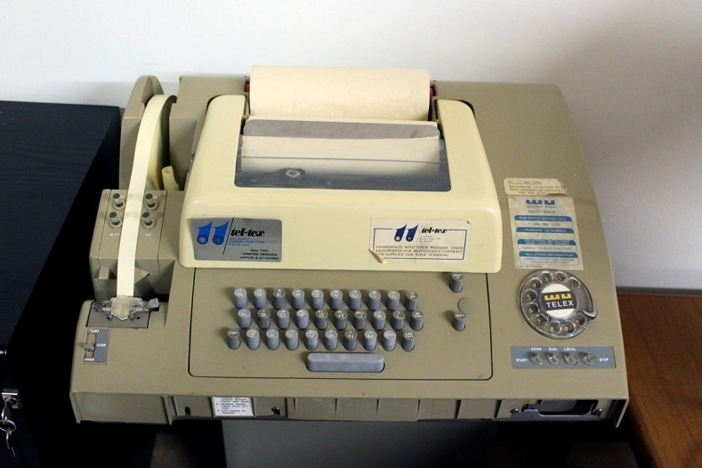

1. **Radio**: It is used to broadcast voice (i.e. audio) information to people who might be in different geographical locations. This is done from Radio Stations.



1. **Television:** This is used to transmit information both in voice (audio) and seeing (vision) from a television station to people in different geographical locations.



**Facsimile (Fax)**: This is a telecommunication device that transmits documents or picture as electronic signals over the telephone system. **It works like a photocopying machine because it makes a copy of the original document and sends it to the receiver.** Fax (short for facsimile), sometimes called telecopying or telefax (the latter short for telefacsimile), is the telephonic transmission of scanned printed material (both text and images), normally to a telephone number connected to a printer or other output device. The original document is scanned with a fax machine (or a telecopier), which processes the contents (text or images) as a single fixed graphic image, converting it into a bitmap, and then transmitting it through the telephone system in the form of audio-frequency tones. The receiving fax machine interprets the tones and reconstructs the image, printing a paper copy.

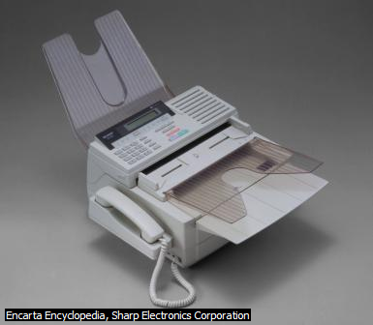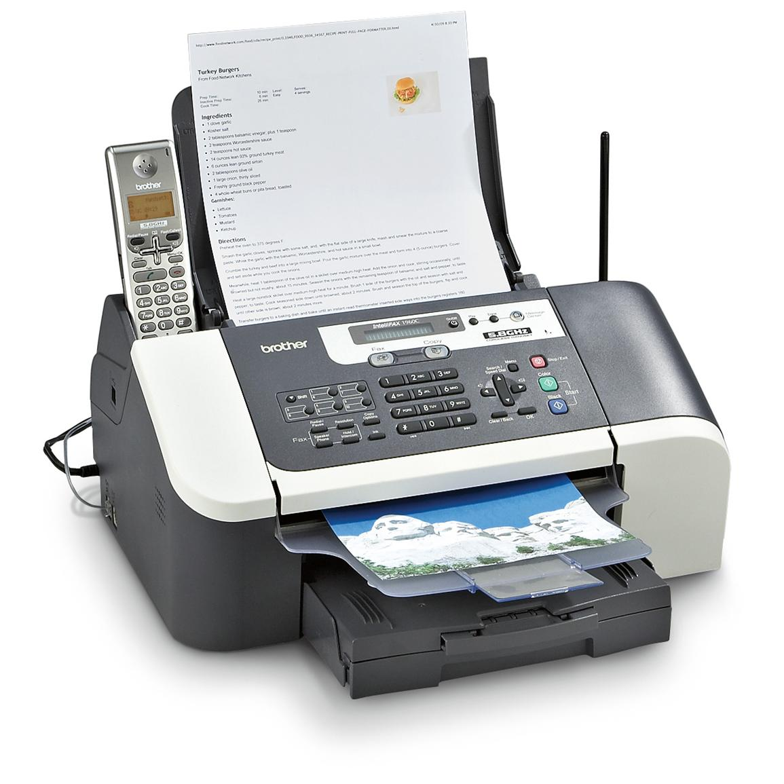

1. **Satellites**: Satellites are used for broadcasting radio and television signals, it allows pictures and sounds to be broadcast live. It is a type of space craft they are also used to transmit telephone signal and high volume data.

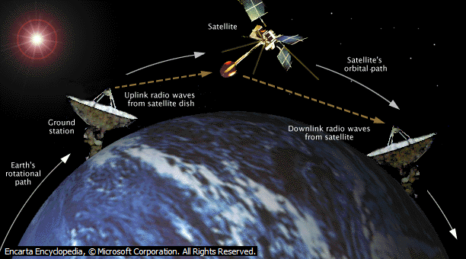

1. **Internet:** It is a collection of computers, all linked together via telephone lines, cables or satellites, to share information worldwide. It is the largest computer network in the world. People can search for information, listen to news, read newspapers, send and receive mails (e-mail) and do many other things on the internet. **The internet is also called NET.**

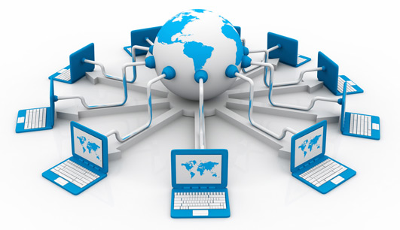

**EVALUATION**

State FIVE modern methods of transmitting information

**WEEKEND ASSIGNMENT**

Read the means of transmitting information and mode of receiving information.

**Objective Question**

1. One of the fastest modern means of transmitting information is not by
2. (a) Drum Beating (b) Internet (c) Radio (d) Television
3. The connection of large number of computer sets is called ___________

(a) GSM (b) Internet (c) Telephone (d) Satellite

1. ____________ is used for broadcasting radio and television signals.

(a) Internet (b) WWW (c) Satellite (d) GSM

1. ____________ is the passing on or publishing of information to an individual or group of people in order to get responses.

(a) Information Technology (b) Information Transmission

(c) Information Communication (d) Informal Transmission

7. Which of the following is **not** a modern way of passing information?

(a) Bush burning (b) Telephone (c) Telex (d) Internet

8. _________ transfer text messages in coded or abridged forms.

(a) Satellite (b) Television (c) Fax (d) Telex

9. Which of the following is the largest computer network in the world?

(a) GSM (b) Television (c) satellites (d) Internet

10. List five methods of modern means of transmitting information.